Linux Symbols:
harshal@cuelogic:~$
harshal@cuelogic:~#

harshal - username
cuelogic - computer’s name
: - separator
~ - home directory
$ - regular user
# - root user
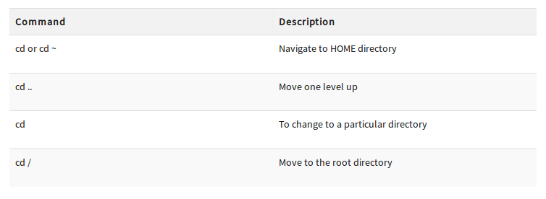
‘chmod’ with Absolute Permissions:
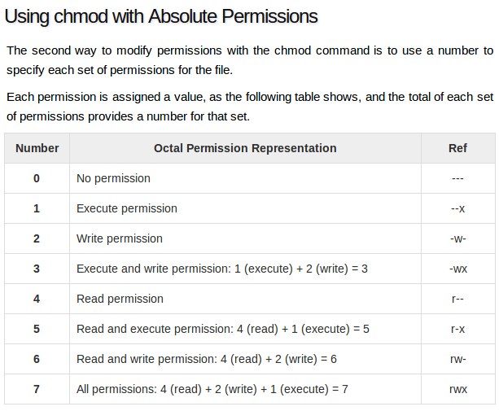
Windows vs Linux:
